Climate Change and the Economy
When former New York Mayor Michael Bloomberg, former Treasury Secretary Henry Paulson, and hedge-fund billionaire Tom Steyer issue a comprehensive report on the severe risks that climate change poses to our economy, it is safe to say that the concept of climate risk has entered into the mainstream.
The report, “Risky Business,” which focuses on the US economy, projects not only stronger and more frequent severe weather events threatening coastal properties, but also significant economic costs such as reduced labor productivity and reduced agricultural yields by up to 70 percent in some U.S. regions. “Risky Business” provides hard data, but Superstorm Sandy and the California Drought are real-life examples of the devastation climate change will bring to our economy if we don’t act now.
The situation is even more dire when we consider the global economy. The map below shows the vulnerability of different regions to the impacts of climate change. Tragically, the effects of climate change are concentrated in historically impoverished nations which have contributed least to the emission of greenhouse gases. If the US, which is in the “low risk” zone, faces tremendous economic challenges due to climate change, the poorest face a true crisis. 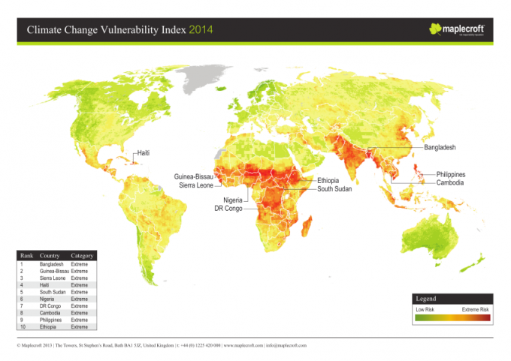

The silver lining is that while climate change poses extreme risks to our economy, tackling the challenge also creates trillion-dollar opportunities. What is required to effectively manage climate change is nothing less than a realignment of our economic and energy systems towards sustainable models. The graph below shows the scale of investment in clean technology that will need to be mobilized in order to avert the worst effects of climate change and maintain a 2°C. The concept of the “Clean Trillion” sums up both the challenge and the opportunity before us – we need trillions of dollars to move into clean investment opportunities in the years ahead. The Tri-State Coalition for Responsible Investment and the Interfaith Center on Corporate Responsibility (ICCR) have begun to develop a program to advance Climate Finance among faith-based investors, starting with a Climate Finance Roundtable at ICCR and a guide to Impact Investing for Climate Solutions.

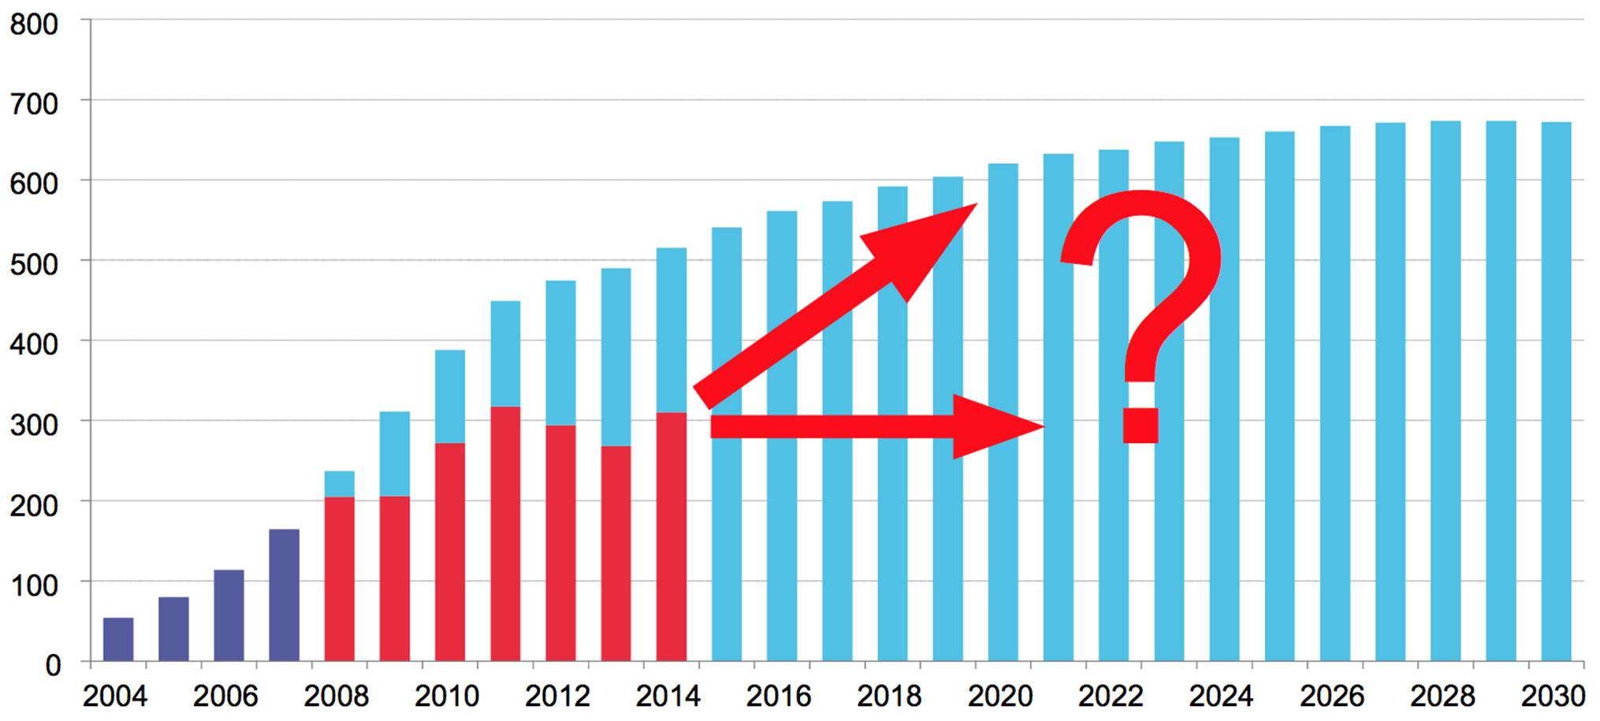

Dominican Sisters have been working with corporations on these issues since 1988, working to shift both our financial and corporate systems towards a sustainable pathway. Through shareholder advocacy, we have used our invested assets in publicly traded companies to obtain a number of corporate commitments related to the climate challenge. After years of engagement, hundreds of companies now measure and disclose their greenhouse gas emissions, and many companies have instituted greenhouse gas reduction goals to manage their climate risk. The recent divestment campaign has built great momentum and focus on climate change. As Preachers, we continue to use our voice to push companies across all corporate sectors to develop goals, stop disruptive lobbying, and address climate risk. Our efforts are making a difference; for example, Citibank recently announced that it will invest $100 billion over the next 10 years in climate finance. And Citibank is just one of many large investment banks internationally that have made additional commitments. When big banks begin taking the environmental effects of their lending and finance into account, we know that the economic shift we seek is beginning to occur. This is heartening news, since we know that adequately addressing climate change demands shifts in the energy and financial markets. Dominicans already have a respected seat at the corporate table, which we have used for years to drive change. The challenge ahead is to evaluate the opportunities and responsibilities that such a position presents.

