11/29/2019
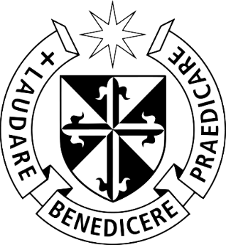

To the Delegates at the UN Climate Change Conference, COP 25

We, the North American Dominican Promoters of Justice, Peace and Care of Creation (NADJPCC), join myriad faith-based organizations in condemning the U.S. withdrawal from the Paris Climate Agreement. This agreement was signed by 197 countries and seeks to prevent catastrophic climate change through coordinated action.
NADJPCC has been involved in promoting the Paris Climate agreement since 2015 at which time members of the Dominican Sisters Conference gathered to begin an in-depth and on-going study of the climate crisis. We selected four delegates who attended the 2015 Paris Climate Conference, COP 21. Since that time, we have continued our study and advocacy on this vital issue. It is unconscionable that the United States is pulling back from the Paris Climate agreement at a time when climate-related events are exacerbating hunger, conflict and global migration.
In concert with the statement by the Leadership Conference of Women religious (LCWR), we believe that withdrawal from this critically important international agreement is profoundly troubling and will not only dishonor our nation but threaten our common home. “Catholic teaching is clear – climate change is a grave moral issue that threatens our commitment to: protect human life and dignity, exercise a preferential option for the most vulnerable, promote the common good, and care for God’s creation.”
As the largest historical emitter of greenhouse gases, the United States has a moral obligation to work with other nations to prevent further climate change and to protect vulnerable people and ecosystems experiencing its effects first and worst. There is growing evidence of climate change on the ground, such as more intense droughts in Central America and East Africa, fires in California and the Amazon and Indonesia, and powerful storms in Asia and the Caribbean. These climate-related events are exacerbating hunger, conflict and global migration.
With deep reference and concern for the Earth Community, and given the dire moral consequences of such withdrawal, the North American Dominican Promoters of Justice, Peace and Care of Creation join other faith-based organizations in condemning the U.S. withdrawal from the agreement

Given the critical nature of the US withdrawal from the agreement, the NADJPCC is sending this letter to our Dominican delegates at the UN Climate Change Conference (COP 25) taking place in December of 2019 in Spain. This conference is designed to take the next crucial steps in the UN climate change process. NADJPCC is asking our delegates to publicly oppose the United States’ withdrawal from the Paris climate agreement and move forward with actions that will benefit all.

In gratitude for the efforts of all to make a difference in this critical issue,

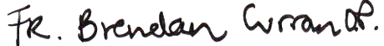
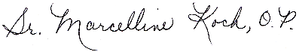
Sr. Marcelline Koch, OP Fr. Brendan Curran, OP
For the North American Dominican Promoters of Justice, Peace, and Care of Creation

Brian Roewe, ‘Catholics call Trump's move from Paris climate deal 'unconscionable'’, National Catholic Reporter - EarthBeat, Kansas City, MO, National Catholic Reporter Publishing Company, https://www.ncronline.org/news/earthbeat/catholics-call-trumps-move-paris-climate-deal-unconscionable , Nov 5, 2019
Leadership Conference of Women Religious, https://lcwr.org/media/news/lcwr-troubled-us-withdrawal-paris-climate-agreement , November 7, 2019

