**Prayer for Women**

**Reading:** Women are often on the frontline in respect to the impacts of a changing climate. We know that climate change affects the poor. Seventy percent of people living below the poverty line are women. More women than men die in weather-related natural disasters. Women typically collect water and fuel, grow and prepare food and care for their families. When natural disaster impacts their communities, women must still provide for the basic needs of their families, often with their own sacrifice, and many without the education, resources, and opportunities available to men. In the wake of such disasters, women find themselves at increased risk for physical abuse and sexual violence. Additionally, women are less able to migrate to look for shelter or work when disaster hits, so they are frequently left to fend for themselves.

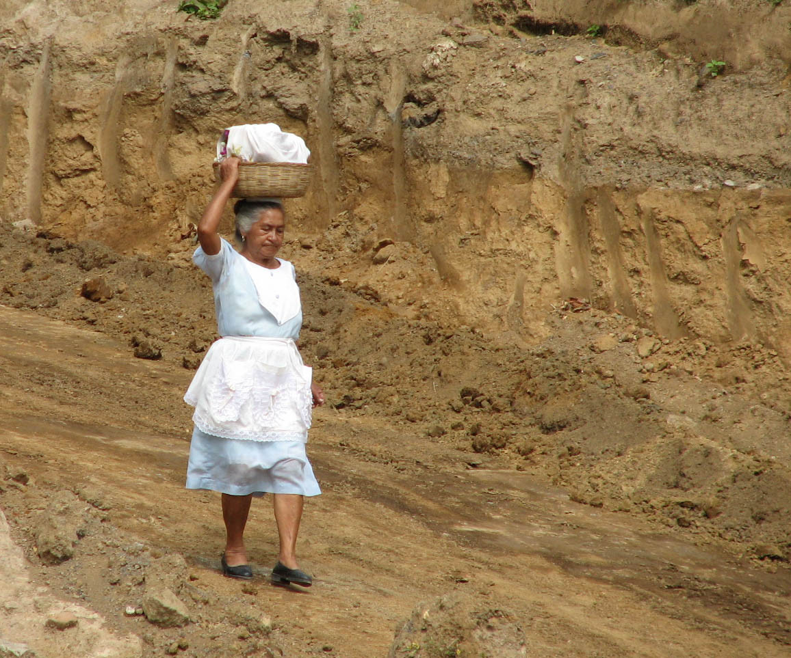

*“ Women will play a critical role in the transition to a cleaner, sustainable environment…Women play an essential role in managing natural resources, and are often much more in touch with their natural surroundings. It is their voices that will ring the loudest in support of policies that encourage the creation of a safe environment for their children.”*

* Dr. Rajendra Pachauri, IPCC Chair

**Generation to Generation**

*A Psalm of Bringing Birth*

Leader: *Women, what will we bring to birth in the world of the new creation?*

All: Wisdom and justice, peace and compassion,

concern for all God’s little ones, for the homeless and destitute, the hungry,

and all who bear the brunt of indifference and oppression.

Leader: *Women, what will we bring to birth on the Earth of the new creation?*

All: A deep respect for our planet, its windsong and waters,

its topsoil and its forests, and a oneness with the wilderness,

that is the image of our soul.

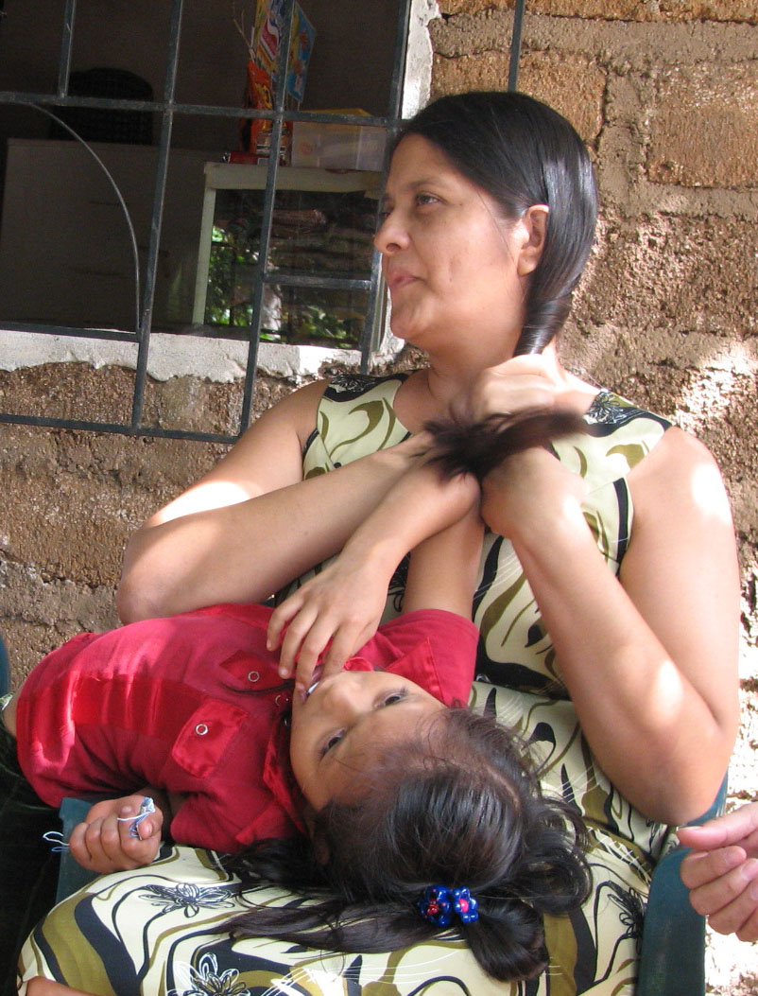

Leader: *Women, what will we bring to birth in  
 the church of the new creation?*

All: A total disdain for power that diminishes or   
 destroys, divestment of wealth and status,

a sharing of human resources based on   
 mutuality and the sudden surprise of grace.

Leader: *Women, what will we bring to birth in  
the hearts of the new creation?*

All: An unbreakable bond in the Spirit that binds   
 as one all brothers and sisters,

transcending class, color, culture, religion   
race and gender, that treats no personal preference, no physical or spiritual difference

as aberration or handicap.

Leader: *One has been born among us who heralds such liberation.*

*Human liberation, women’s liberation, has taken flesh among us*

*and in Spirit dwells with us.*

All: Holy the woman who helped this happen.

Blessed are we when we give birth to the Word made flesh in us.

- Miriam Therese Winter in ***Woman Word***