**A LITANY OF THE CIRCLE**

Leader Every part of Earth is sacred,

Every shining pine needle, every sandy shore, ‘

Every mist in the dark woods,

Every clearing, every humming insect is holy.

All Every part of Earth is sacred.

Speaker 1 The rocky crest, the juices of the meadow,

The beasts and all the people,

All All belong to the same family.

Speaker 2 Teach your children that Earth is our mother.

Whatever befalls Earth befalls the children of Earth.

The water’s murmur is the voice of our parent’s parent.

All We are part of Earth, and Earth is part of us.

Speaker 1 The rivers are our brothers, they quench our thirst.

The perfumed flowers are our sisters.

The air is precious,

All For all of us share the same breath.

Speaker 2 The wind that gave our grandparents breath   
Also receives their last sigh.

The wind gives our children the spirit of life.

This we know, Earth does not belong to us,

All We belong to Earth.

Speaker 1 This we know, all things are connected,

Like the blood which unites one family.

Our God is the One whose compassion is equal for all.

All All things are connected.

Speaker 2 For we did not weave the web of life.

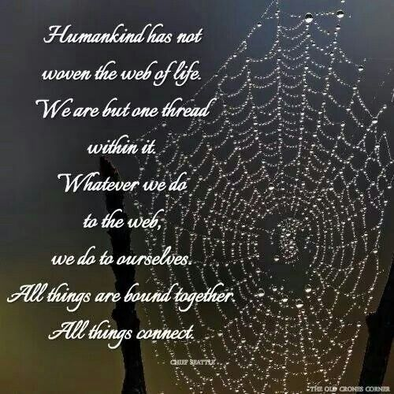

All We are merely a strand.

Speaker 1

Whatever we do to the web

ALL We do to ourselves.

Speaker 2

Let us give thanks for the web and the circle that connects us.

All Thanks be to God, the God of all.

(Adapted from a talk given by Chief Seattle)

**Reading from Galatians**

*By contrast, the fruit of the Spirit is love, joy, peace, patience, kindness, generosity, faithfulness, gentleness, and self-control. There is no law against such things . . . If we live by the Spirit, let us also be guided by the Spirit. Let us not become conceited, competing against one another, envying one another.*

**Reflection from The Green Bible Devotional**

*Imagine what the earth would be like if we all practiced these fruits of the Spirit. Because we are created by God, because all of humanity was imbued with God’s Spirit at Creation, because we are called to live as God’s people in the world, we are to bear these fruits. When we do, it becomes impossible to do damage to [Earth or] our brothers and sisters around the world. We cannot be people of peace while creating strife for others. We cannot be people of self-control when we are only thinking of our own interests. When we seek to be people who live out the fruit of the Spirit, we simply cannot do anything but live as God intended.*

**Closing Prayer**

Gracious God, tend to us so that we might produce your good fruit. Turn over the hardened soil of our hearts and bring back the rich ground in which your Spirit can thrive. Help us to live as your people. Amen